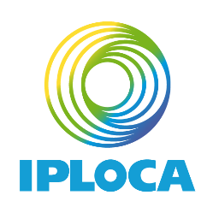

APPLICATION FOR CANDIDATURE
AS
2023-2024 IPLOCA BOARD MEMBER

If you wish to run for a vacant seat, please complete this form and send it to juan.arzuaga@iploca.com with your brief résumé and a head and shoulder photograph before the deadline, 22 August 2023.
The application will then be forwarded to the incumbent Director. Seat assignments will take place at the Nomination Meetings held during the 2023 Annual Convention in Vancouver, Canada.
NOTE: The language of the association is English (By-laws, clause 17). All candidates must speak and write English fluently to be considered.

- Name and Title ____________________________________________________

- Company Name _____________________________________________________

- Representing

□ Regular Members

__________________________________________(Geographic Region)

Or

□ Associate Members

__________________________________________(Geographic Region)

- Why are you interested in serving on the Board? (If you require more space, attach a separate sheet of paper)

- What contribution do you believe you can make towards helping IPLOCA achieve its objectives listed in the By-laws?

- If you would like to achieve one goal during your term of office, what would it be?

- What other volunteer commitments do you currently have?

I have read and agree to the responsibilities and requirements of being an IPLOCA Board Director.

Signature __________________________________________ Date______________________

My application is supported by the following senior management representative in my company.

_______________________________________________________________________________

Return this completed form along with your brief résumé and a photograph as soon as possible to juan.arzuaga@iploca.com

